# Web Review Exercise 1

In a new web page, provide a form field where the user can enter a number. Also provide a button.

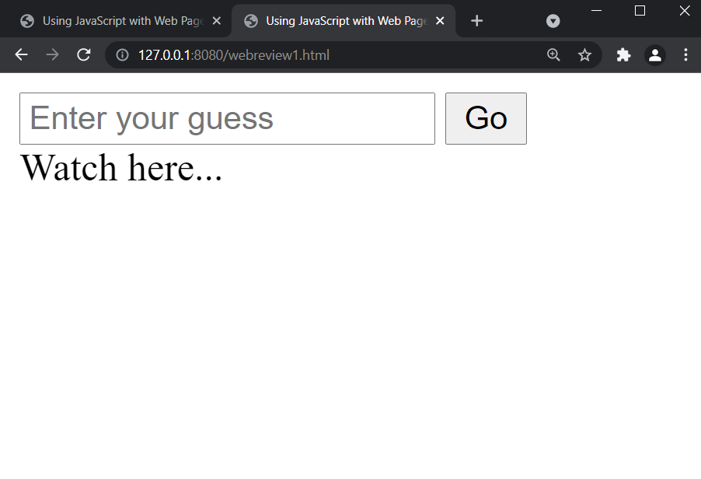

In a script block, add a click-event listener to the button, which invokes a function.

The function checks if the number is greater, less or equal to a random number (such as 1-100).

Tell the user if they got it right, or if it is too low or too high.

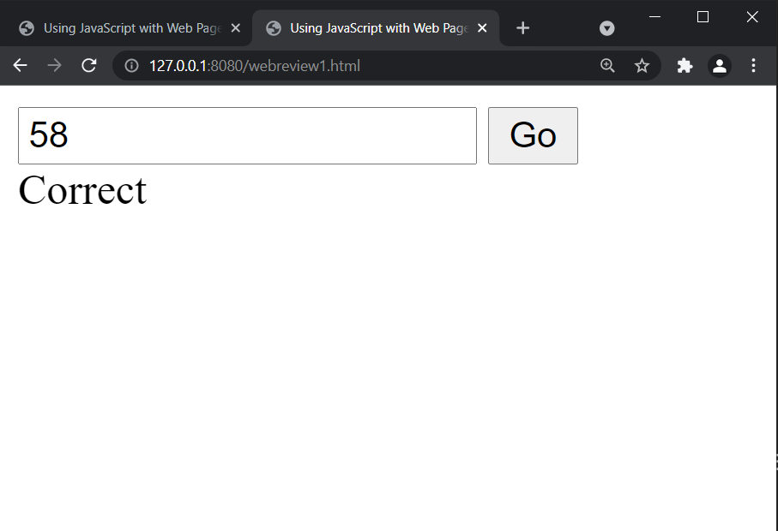

## Optional

Every time they make a guess, add one to a ‘count’ variable. When they get it right, tell them how many guesses they had.

If they enter -2 tell them the answer.

If they enter -1 give a clue, such as ‘it is an odd number’ or ‘it is a square number’.